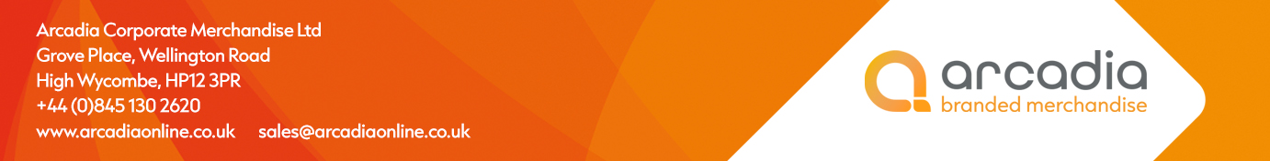

D E L I V E R Y N O T E

Deliver to:
Ayesha Mahmood
Nomura International Plc
One Angel Lane
London
EC4R 3AB

Delivery date: 4th March 2026

Description:

80 x Sports Bags

Branding: Nomura logo

Arcadia Ref: 148742 CRM: 38402
Clients Ref: .

