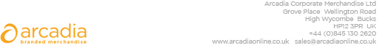

D E L I V E R Y N O T E

Tracey Reed
Urenco Ltd
URENCO Court, Sefton Park
Bells Hills
Stoke Poges
Bucks
SL2 4JS

Delivery date: 22nd November 2024

Description:

200 x Cooler Bags

Branding: Urenco Energy to Succeed Logo
Arcadia Ref: 138517 CRM: 36489
Clients Ref:

