Thank you for getting in touch. I assume that this order will only be around 3 boxes to deliver, therefore we have a new work around in place whereby although you will still need to book a specific day with VOW for delivery, your courier can deliver anytime that morning.

I have listed the process below, please let me know if this would work, otherwise I will provide another delivery address.

Box Traffic Booking in Procedure

Obtain AM open booking slot from adcgoodsin@evo-group.co.uk
Deliveries accepted up to 12 noon on booking date.
Put the delivery note in a documents enclosed envelope on the outside of the box (example below)
Print / write the following on the outside of the box;
PO number
FAO Goods In
Booking reference

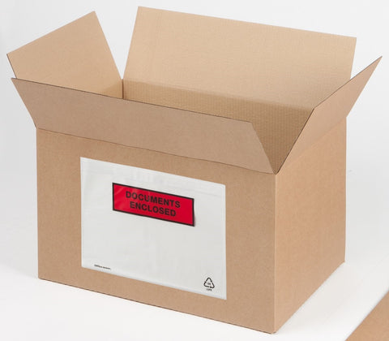

I look forward to hearing from you.

Reagrds

Claire

