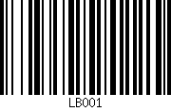
Brand:
Lloyds British
Product Description:
A5 Notebook
Product Colour:
Dark Blue
Unit of Measure: P.O. Number:
BOX40 38496

Brand:
Lloyds British
Product Description:
A5 Notebook
Product Colour:
Dark Blue
Unit of Measure: P.O. Number:
BOX40 38496

Brand:
Lloyds British
Product Description:
A5 Notebook
Product Colour:
Dark Blue
Unit of Measure: P.O. Number:
BOX40 38496

Brand:
Lloyds British
Product Description:
A5 Notebook
Product Colour:
Dark Blue
Unit of Measure: P.O. Number:
BOX40 38496

