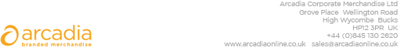

D E L I V E R Y N O T E

Delivery address:

Paragon Customer Communications
41-44 Stapledon Rd
Orton Southgate
Peterborough
PE2 6TH
Lee Tiffin – 01733 368407

Description:

1495x Bags

Branding: CityFibre

Arcadia Ref: 131655 CRM: 33261
Clients Ref: CFH00045292

