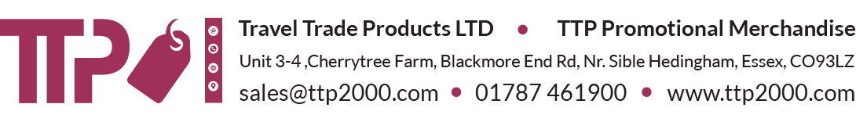

DELIVERY NOTE

Customer: Amazon UK Services Ltd

Order No: 10646

FAO: Mark Chew

Amazon UK Services Ltd
4 Sixpools Grove
Ellenbrook
Manchester
M28 7GR

Tel: 07799868499

METHOD OF DESPATCH:
---------------------------------------------------------------------
PLEASE RECEIVE THE FOLLOWING GOODS

100 x Royal Blue Lunch Bags

Signature Print Date

