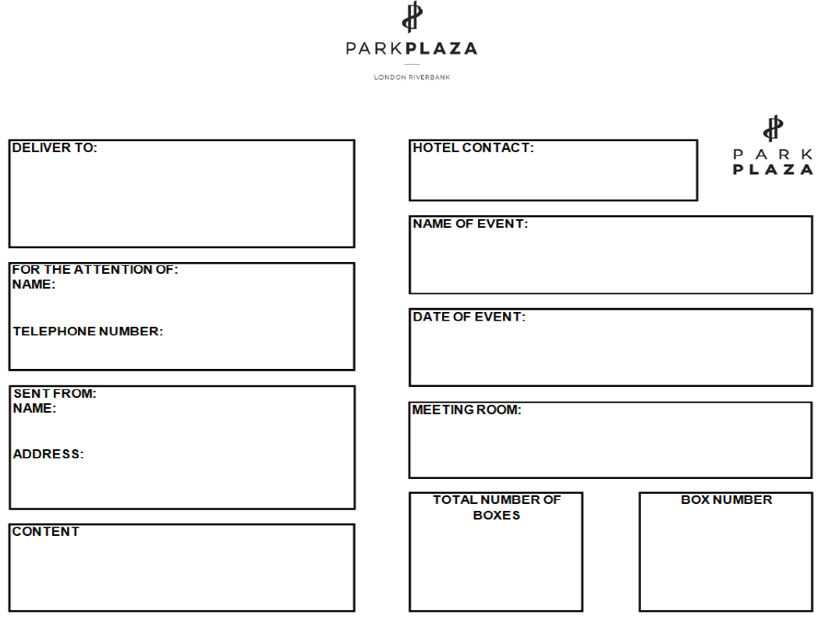
Order Number - 26552
Lotmead Business Park, Wanborough, Wiltshire, SN4 0UY
Saturday 21st May
PA Consulting - Global Partner Meeting 2022
Sofiena Achab - M&E Operations Manager
Sofiena Achab - M&E Operations Manager
Park Plaza Riverbank Hotel
18 Albery Embankment
London SE1 7TJ
Venues & Events International Ltd - Kira Clinton

270 x Bags

x
1
x
1

