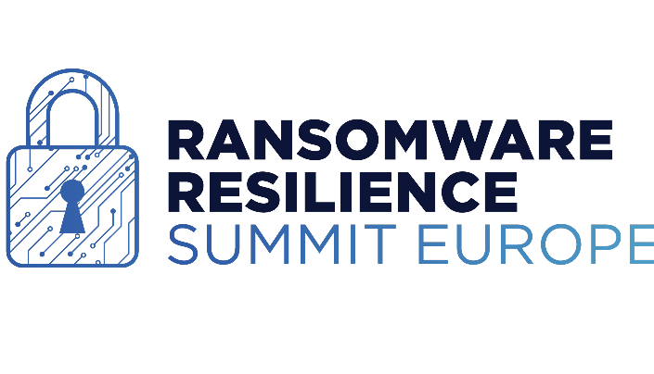
Delivery Location:
15Hatfields
Chadwick Court
London SE1 8DJ

Event:
Ransomware Resilience Summit Europe
22nd – 23rd February

Organiser’s Name:
Kisaco Research – Amy Butler 07517 156 031

Sending Company Name:
Firebrand Promotions Ltd
…………………………………………………………………………………………

Sending Company Contact:
(Name & Cell Number)
Andrew Bourne 07813 023101
……………………………………………………………………………………
Box number ______ of ______
DELIVERIES WILL ONLY BE ACCEPTED FROM 17/02/2022
BEFORE THIS DATE ITEMS WILL NOT BE ACCEPTED

