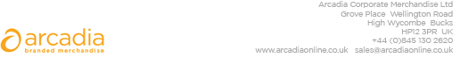

D E L I V E R Y N O T E

Becky Collins
SAP
5th Floor,
6 Ramillies St,
Soho,
London
W1F 7TY

Delivery date: 29th January

Description:
500 x Notebooks
100 x Laptop Bags
Branding: SAP logo

Arcadia Ref: 120132 CRM: 29400

