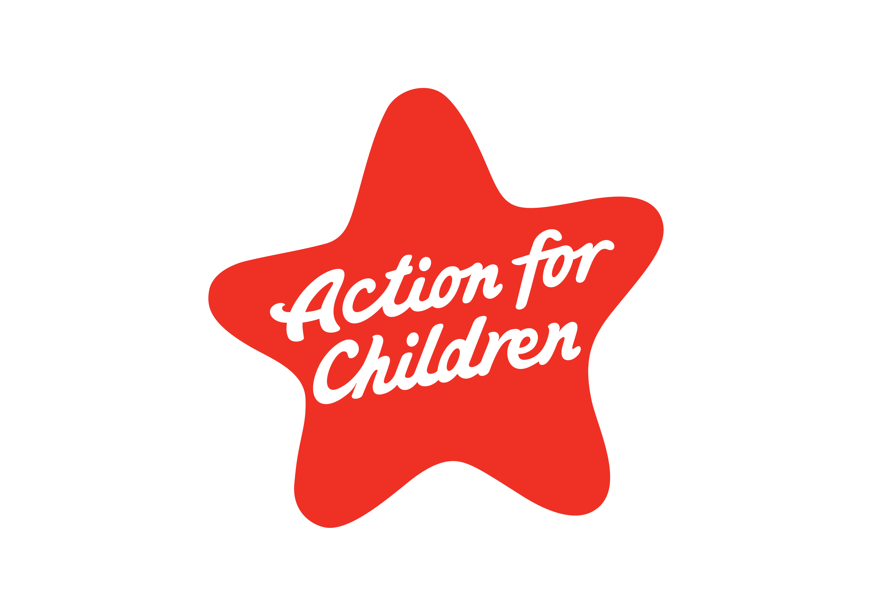
Codestorm Limited
Codestorm House
Walton Road, Farlington
Hampshire PO6 1TR
Description: Welsh Notebook
SKU: 21980
Quantities: 499
Registered charity nos. 1097940/SC038092/company no. 4764232. © Action for Children 2019.

