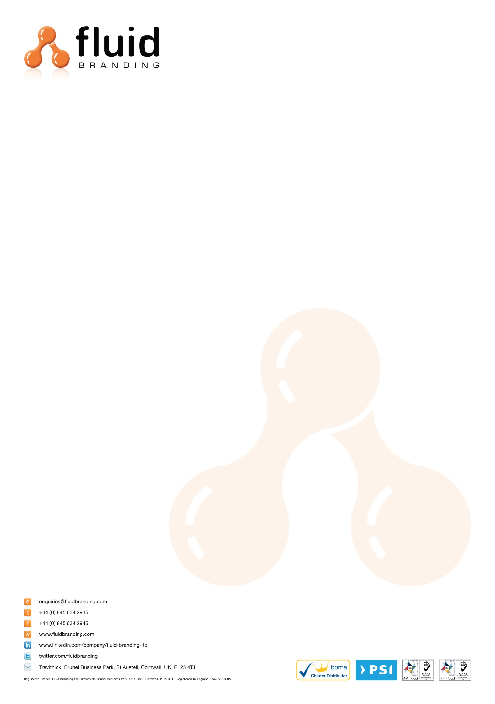
COMMERCIAL INVOICE
Date: 13th June 2019
Collection Address:
BAGCO LTD
BULLHOUSE MILL LEE LANE
MILLHOUSE GREEN
PENISTONE
SHEFFIELD
S36 9NN

Tel: 01959 560500
Description of Goods (and quantities) with Commodity Codes
200x Eynsford Drawstring Bag - Royal Blue – 42029291

Material: Polyester
Unit cost: £1.65
Total shipment cost: £330.00
Purpose of Shipment: Sold
For: Promotional Use

INCO TERMS: DDP

Delivery Address:
Jon Allo
Advertising International
7 Bath Street
St. Helier
Jersey
JE2 4ST
Tel: 01534837336
When shipping please ensure that all duties and taxes are billed to Fluid Branding Ltd. and NOT the receiver. I declare that all information in this invoice to be true and correct.
Senders Billing Address:

Fluid Branding Ltd
Brunel Business Park
St Austell
Cornwall
PL25 4TJ

EORI NUMBER: GB886818361000
VAT NO: 886818361
Print: Jessica Patton
Signed: J.Patton

