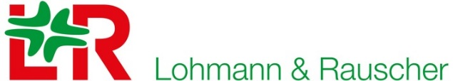

Required Label Information

Company Title: L&R UK
SAP Reference: 9507732
Required description: ReadyWrap Bags
Required case Quantity: (100)

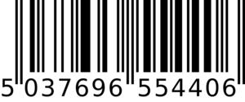

100per box

BOX OF

