Arcadia Supplier Information

We would like to inform you of the important changes which are now in effect, as these will impact the way we currently work with you.

Packing & Labelling

- Goods must be packed as per our PO (ie packed in 100’s, poly bagged, shrink wrapped per 10, etc) PLEASE NOTE THIS IS ONLY APPLICABE IF ON OUR PO

- Arcadia will provide you with a completed label template. Outer boxes must be labelled with these labels. Do not supply mixed product codes in cartons.

- This is an example of our labelling:-
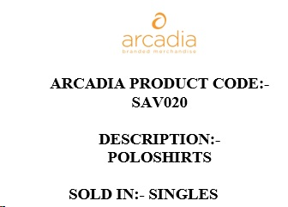

- Arcadia must be notified of expected order despatch at least 2 days in advance of despatch.
- Deliveries of more than 1 pallet MUST BE BOOKED IN. Contact your Arcadia Buyer.
The above process is in place with immediate effect. Failure to comply will result in the supplier collecting/ labelling and packing the goods correctly.
If you have any concerns about the above or you are not able to pack/label goods as requested, please contact the Arcadia Buyer before goods are despatched.

