

In partnership, with

Dear Sir/Madam
You are receiving this document as you will have received an order that will be branded and delivered to an Amazon site.
All deliveries to any Amazon sites have specific instructions that will need to be followed. If you do not adhere to the below we will not be liable for the cost of the goods as Amazon will not pay any invoice for them.
Please make us aware before goods are proofed if you do not agree to these instructions as we will need to source elsewhere.
Shipping Instructions
All boxes that are being despatched will need to be clearly marked with ‘XXXX – Non-Inventory Goods’
XXXX denotes the Site Code and Number – this will be advised at time of order
Every side of the box will need to have the below blue packaging slip added to it (also attached as separate file), you will also need to add one of these inside the box.
We will need to be provided with photographs showing that this has been done.
Please ensure goods delivered can always be unloaded through a bay door or alternatively be specified as side unloading only to ensure Amazon can accept the delivery
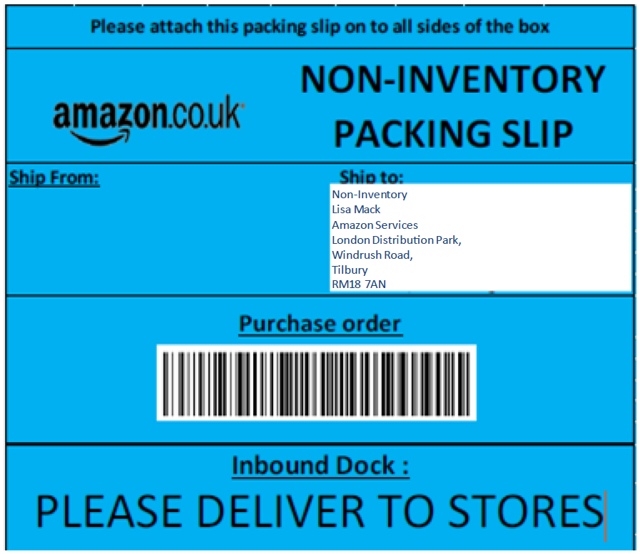
EXAMPLE
When despatched with a 3rd party courier we will require a photograph at point of delivery/POD.

Courier Preference is DPD.

Many thanks
Outstanding Branding.

