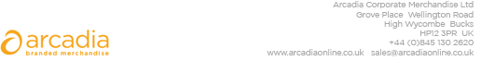

D E L I V E R Y N O T E

Delivery address:

Kalpana Padhiar
Customer Experience Manager
Euler Hermes
Norfolk House
7 Norfolk St
Manchester
M2 1DW

Delivery Date: 28th August 2018

Description:

100 x Chatham Gift Bag

Branding Details:- Euler Hermes Taking Care of Customer

Arcadia Ref: 104630 CRM: 23910
Clients Ref:

