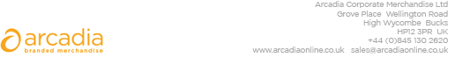

D E L I V E R Y N O T E

Delivery address:

Kelly Power
Hogan Lovells International LLP
Atlantic House
Holborn Viaduct
London
EC1A 2FG

Delivery Date: 3rd July 2018

Description:

600 x Allington bag 12oz Cotton Canvas Tote Bag
Colour:- Black bags

Branding Details:- Hogan lovells logo

Arcadia Ref: 102644 CRM: 23331
Clients Ref:

