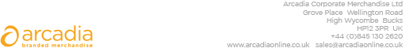

D E L I V E R Y N O T E

Delivery address:

Wendy Levinson
Nice Systems UK Ltd
160 Queen Victoria Street
LONDON
EC4V 4BF

Delivery Date: 24th May 2018

Description:

400 x Chatham Budget Tote/shopper Bag
Colour Bag:- WHITE

Branding Details:- Nice Logo

Arcadia Ref: 101446 CRM: 22863
Clients Ref: 5024152

