GRANGE TOWER BRIDGE HOTEL
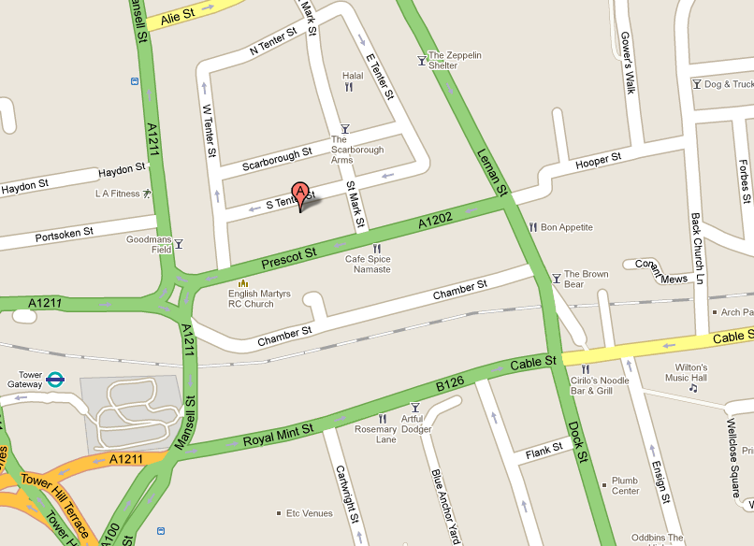
GOODS DELIVERY. St. Mark st.
All packages being sent for your event must be labelled correctly ( see label here under)

All deliveries must be made through the ‘Goods Delivery’ bay situated at the rear of the hotel where Prescot Street meets St Marks Street. Deliveries should arrive at the hotel no more than 24 hours prior to the event and must be delivered between 9am-7pm Monday to Friday, 8am-12pm Saturday and Sunday, any deliveries made outside of this time will not be accepted due to local government planning consent. Please also note the maximum length must not exceed 20ft and the maximum weight of the vehicle must not exceed 18 tonnes.
Please also note storage within the hotel is very limited. We will need to discuss if you require storage of any equipment overnight in our venue post event to be collected the following day.


GRANGE TOWER BRIDGE HOTEL

DELIVERY FORM

HOTEL ADDRESS: 45 Prescot Street / E1 8GP London (Tel: 0207 959 5000)
(Delivery area on St Marks Street)

DATE OF EVENT: 12/11 EVENT ROOM: Beaumont

CLIENT NAME: Kym Osborne

CLIENT CONTACT NUMBER: 020 7017 684

COMPANY NAME: KNect365

HOTEL EVENT ORGANISER NAME: Silvia Giraldo

Parcel number 1 of 3

GRANGE TOWER BRIDGE HOTEL

DELIVERY FORM

HOTEL ADDRESS: 45 Prescot Street / E1 8GP London (Tel: 0207 959 5000)
(Delivery area on St Marks Street)

DATE OF EVENT: 12/11 EVENT ROOM: Beaumont

CLIENT NAME: Kym Osborne

CLIENT CONTACT NUMBER: 020 7017 684

COMPANY NAME: KNect365

HOTEL EVENT ORGANISER NAME: Silvia Giraldo

Parcel number 2 of 3

GRANGE TOWER BRIDGE HOTEL

DELIVERY FORM

HOTEL ADDRESS: 45 Prescot Street / E1 8GP London (Tel: 0207 959 5000)
(Delivery area on St Marks Street)

DATE OF EVENT: 12/11 EVENT ROOM: Beaumont

CLIENT NAME: Kym Osborne

CLIENT CONTACT NUMBER: 020 7017 684

COMPANY NAME: KNect365

HOTEL EVENT ORGANISER NAME: Silvia Giraldo

Parcel number 3 of 3

