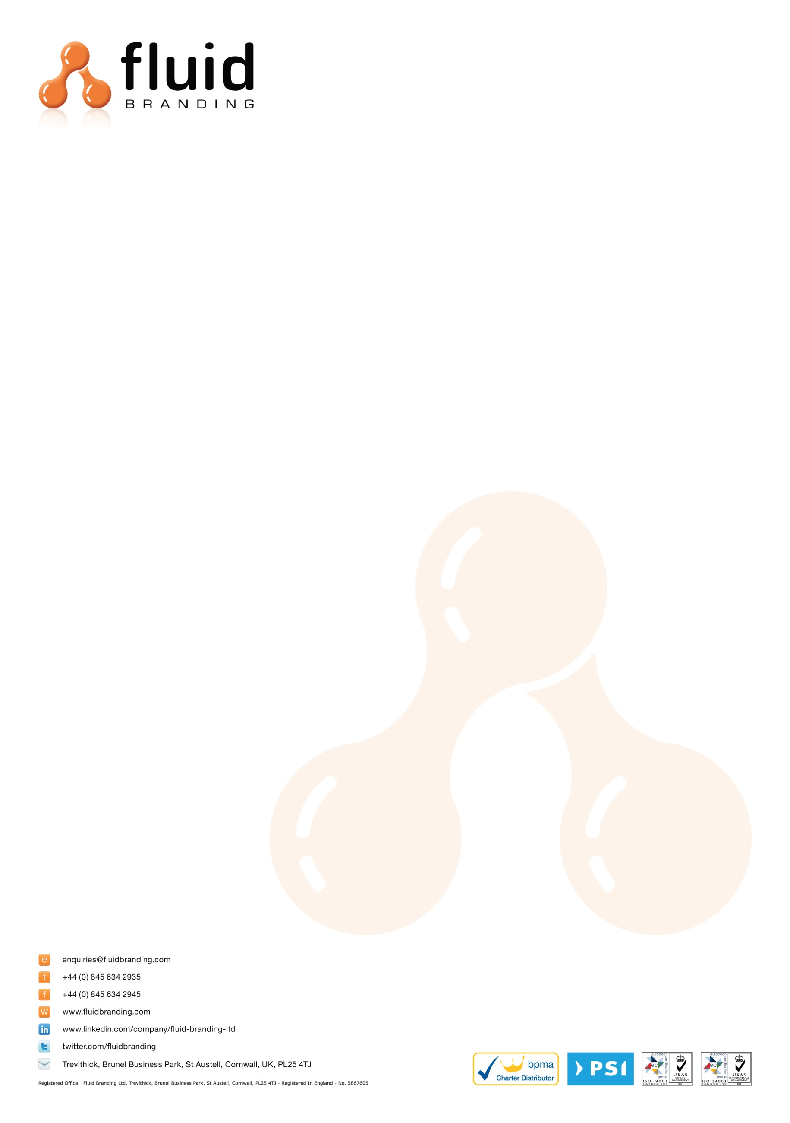
COMMERCIAL INVOICE
Date: 15th November 2017
Collection Address:
BAGCO LTD
BULLHOUSE MILL LEE LANE
MILLHOUSE GREEN
PENISTONE
SHEFFIELD
S36 9NN

Tel: 01959 560500
Description of Goods (and quantities) with Commodity Codes
Eynsford Drawstring Bag - Royal Blue – 42029291

Dimensions: 47(h)x38(w) cm
Weight: 0.08kgs
Material: Polyester
Quantity: 200 units
Unit cost: £1.55
Total shipment cost: £310.00
Purpose of Shipment: Sold
For: Promotional Use

Delivery Address:
Becky Kinross
Advertising International
7 Bath Street
St. Helier
Jersey
JE2 4ST
Tel: + 01534 730001

When shipping please ensure that all duties and taxes are billed to Fluid Branding Ltd. and NOT the receiver.
I declare that all information in this invoice to be true and correct.
Print: Jessica Patton
Signed: JPatton

