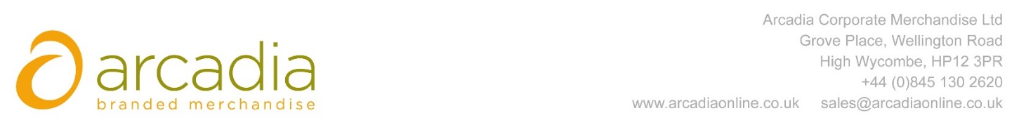

D E L I V E R Y N O T E

Delivery address:

Vicky Mogford
Bidfood Business Support Centre
814 Leigh Road
Slough
SL1 4BD

Delivery Date: 3rd October 2017

Description:

150 x Rainham 12 can cooler bag

Arcadia Ref: 95047 CRM: 20744
Clients Ref: 894118

