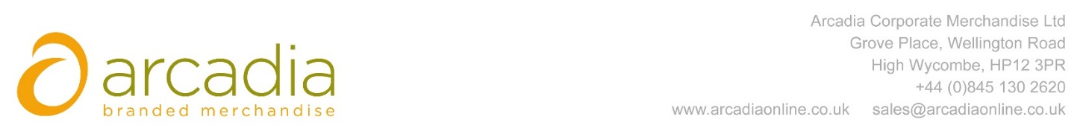

D E L I V E R Y N O T E

Delivery address:

Melissa Wong
Cass Business School
106 Bunhill Row
London
EC1 8TZ

Delivery Date: 11TH September 2017

Description:

350 x 4.5oz Natural Cotton Tote bag

Branding Details: Boosting Resilience

Arcadia Ref: 94216 CRM: 20469
Clients Ref:

