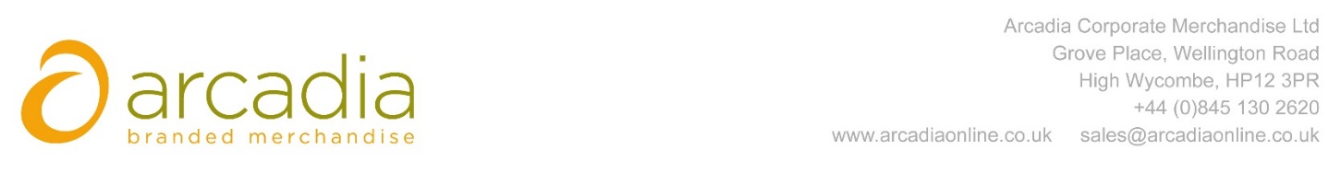

D E L I V E R Y N O T E

Delivery address:

Amanda Sarson
Blandy & Blandy Llp
One Friar Street
READING
RG1 1DA

Delivery Date: 17th August 2017

Description:

250 x 4.5oz Cotton Tote Bags-Natural

Branding Details: Blandy & Blandy

Arcadia Ref: 93636 CRM: 20235
Clients Ref:

