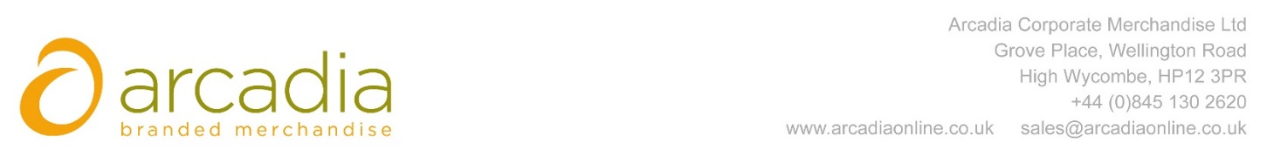

D E L I V E R Y N O T E

Delivery address:

Fenella McElroy
Bidfood
Main Reception
814 Leigh Road
Slough
SL1 4BD

Delivery Date: 29th June 2017

Description:

125x Cooler Bags

Branding: Bidfood

Arcadia Ref: 92363 CRM: 19817
Clients Ref:

