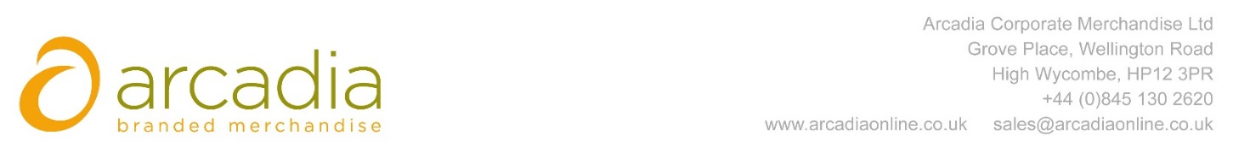

D E L I V E R Y N O T E

Delivery address:

Saralyn Burton
City University London
Northampton Square
London
EC1V 0HB

Delivery Date: 28th June 2017

Description:

1700x Canvas Bags

Branding: City Law

Arcadia Ref: 92305 CRM: 19800
Clients Ref:

