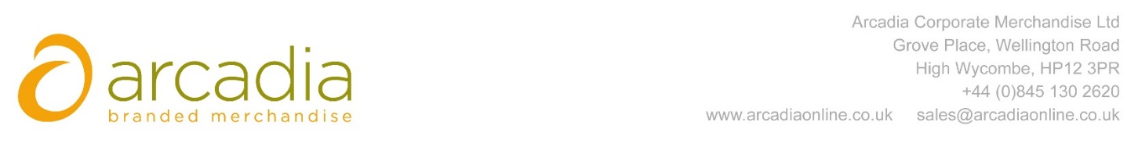

D E L I V E R Y N O T E

Hester Wellings
City University London
Northampton Square
London
EC1V 0HB

Delivery date – 16TH June

Description:

150 X Bags branded with Lead
Arcadia Ref: 91993 CRM: 19694
Clients Ref:

