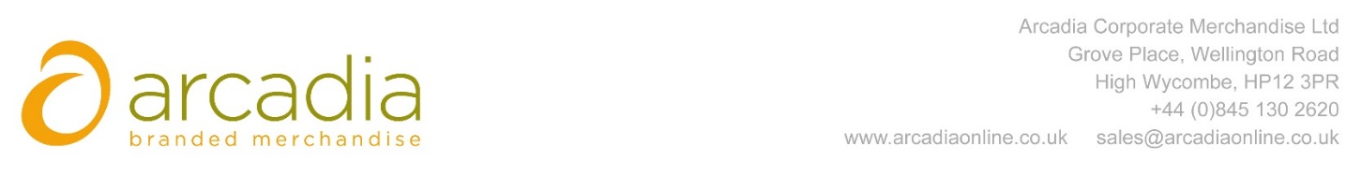

D E L I V E R Y N O T E

Delivery address:

MARY-SIMPLE PUSE
RGA INTERNATIONAL REINSURANCE COMPA
31-33, RUE DE LA BAUME
75008 75008 PARIS, FRANCE
France

Delivery Date: 12th June 2017

Description:
160x Bags

Branding: RGA Logo
Arcadia Ref: 91839 CRM: 19628
Clients Ref:

