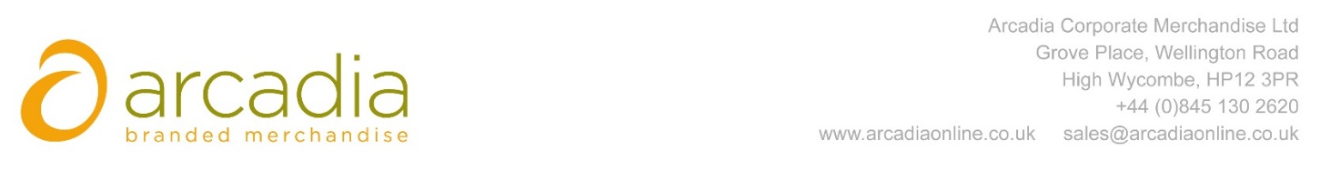

D E L I V E R Y N O T E

Delivery address:

Hazel Frier
Main Reception
Bidfood
814 Leigh Road
Slough
SL1 4BD

Delivery Date: 28th April 2017

Description:
125x Cool Bags

Branding: Bid Food Logo
Arcadia Ref: 90707 CRM: 19308
Clients Ref:

