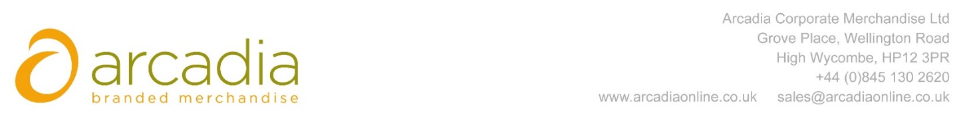

D E L I V E R Y N O T E

Delivery address:

Kevin Keegan
Fidessa
Dukes Court
Duke Street
Woking
Surrey
GU21 5BH
Delivery Date: 31st March 2017

Description:

2000 x Drawstring Bag

Branding Details: Fidessa Logo
Arcadia Ref: 89858 CRM: 19026
Clients Ref: Kevin Keegan

