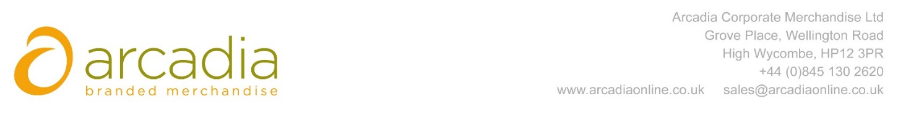

D E L I V E R Y N O T E

Delivery address:

Sarah English
E2b logistics – ZEO
UNIT A1 &B1
GREATHAM ROAD
WATFORD
WD23 2NZ

Delivery Date: 28th March 2017

Description:

20 x Backpacks

Branding Details: Zeo Logo
Arcadia Ref: 51919 CRM: 19001
Clients Ref: Sarah English

