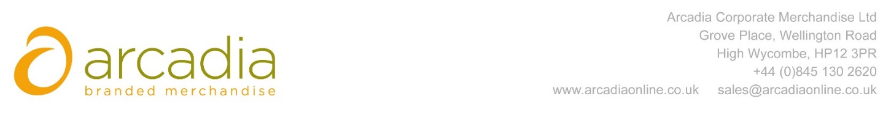

D E L I V E R Y N O T E

Delivery address:

Melanie Bassett
Chadwick Nott
2nd Floor
25 King Street
Bristol
BS1 4PB

Delivery Date: 7th March 2017

Description:

500x Somerhill Bags

Branding Details: Chadwick Nott

Arcadia Ref: 88233 CRM: 18815
Clients Ref:

