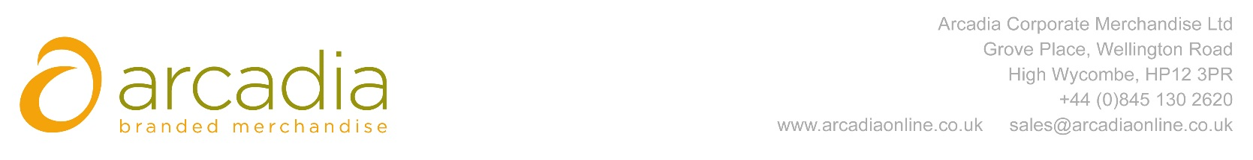

D E L I V E R Y N O T E

Delivery address:

FAO Fran Forsyth
Allianz Insurance Plc
57 Ladymead
Guildford
Surrey
GU1 1DB

Delivery Date: 19th January 2017

Description:

300x Drawstring bags

Branding details: Allianz

Arcadia Ref: 88136 CRM: 18482
Clients Ref:

