 BTC Group Goods In procedure // Jan 2016
Prior to delivery
- All pallet deliveries must be booked in at least 24 hours before its arrival date.
- To book in deliveries telephone 0208 587 3352 or email goodsin@btcgroup.co.uk
- Stating;
      - Number of pallets,
      - BTC Purchase Order Number
      - Full Description of goods
Opening times - Goods In
The warehouse is open 08.30-17.00 Monday to Friday. Deliveries outside these hours will be by arrangement only.

Deliveries should be made to:
Goods In
BTC Group
BTC House,
9 Millington Road,
Hayes, Middlesex
UB3 4AZ.
Delivery specification
All materials must be properly boxed, sealed and labelled, in good quality cartons that provide adequate protection during transit and storage and accompanied by the correct paperwork (see below).
Whilst you should not mix different items in the same carton, mixed pallets are acceptable providing the paperwork states a full breakdown and the label on the boxes is clear.
Delivery Notes
Every delivery must have a delivery note stating.
BTC Group contact name
PO Number
Item description (and code where applicable)
Total quantity of the items being delivered
Breakdown of any shortages
Packing specifications for boxed items
- Items should be packed in boxes that are of adequate strength
- No mixed contents in boxes or cartons
- Each carton must be packed to capacity to avoid crushing/damage by content movement
- Carton weight must not exceed 20kg
- Boxes must be properly sealed and labelled with, Item description and quantity within carton.
Packaging specifications for palletized items.
Pallets should be 1200mm x 1000mm (4-Way with full perimeter base), of sturdy construction and no more than 1600mm high and 900kg in weight.
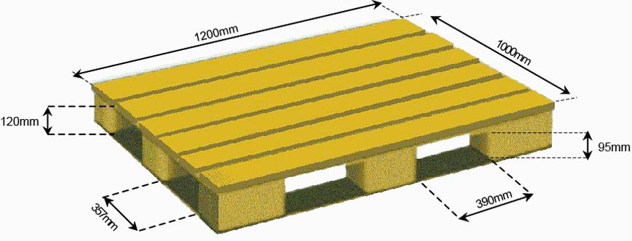

They must be brick-stacked, stretch shrink wrapped and labelled with the following information:
- Item description.
- Quantity of cartons.
- PO Number

Please note : Any deliveries that do not confirm to the above specification, ie not accompanied by the correct paperwork, packed incorrectly or damaged in transit may be turned away and/or attract additional handling charges which will become responsibility of the delivering supplier.

Getting to BTC Group
www.btcgroup.co.uk
Sat Nav Post Code; UB3 4AZ

