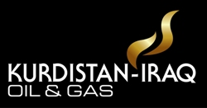
Sarah White
Event Manager

For the attention of:

Address:

Receiving Bay

Lancaster London

London Terrace, Westminster

London, W2 2TY

United Kingdom

Event:
Kurdistan-Iraq Oil & Gas
Date:
30 November-
2 December 2015
Organiser:
The CWC Group Urszula Kwintal

NAME OF EVENT:
:
Event Room:
Westbourne Suite

SENDER DETAILS
Company Name:

Company contact details:

CONTENTS:

BOX OF

