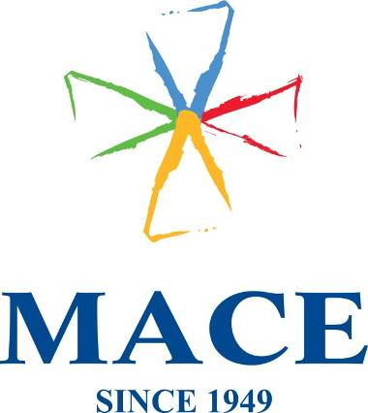

Mace (Ireland) Ltd. · Block 2, West Pier Business Campus, Old Dun Leary Road · Dun Laoghaire ·
Co. Dublin · Tel: +353 (0) 1 2802909

DELIVERY NOTE

Delivered To:
FAO EMC3
Rachael O'Higgins
THE STUDIO, 51 Lever Street, Manchester, M1 1FN, UK
Phone: 087-1725950

Packing list:
130 Hubspot Orange Cotton Tote Bag
OUR REF: SOR060354/POR056371

Delivered By:
Mace (Ireland) Ltd
Michelle Roe
Block 2, West Pier Business Campus
Old Dunleary Road
Dun Laoghaire
Co Dublin

Phone: 01-2145101

BOX _____ of _____

