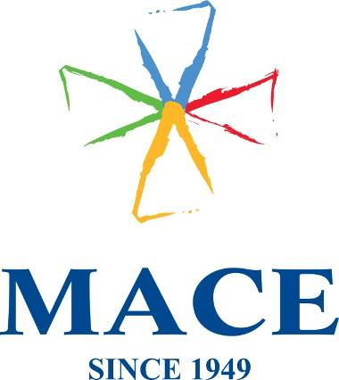

Mace (Ireland) Ltd. · Block 2, West Pier Business Campus, Old Dun Leary Road · Dun Laoghaire ·
Co. Dublin · Tel: +353 (0) 1 2802909

DELIVERY NOTE

Delivered To:
FAO: FAO EMC3
Rachael O'Higgins
THE BREWERY, 52 Chiswell Street, London, EC1Y 4SD, UK
Phone: 0871725950

Packing list:
170 Hubspot Orange Cotton Tote Bag
OUR REF: SOR060354/POR056371
Delivered By:
Mace (Ireland) Ltd
Michelle Roe
Block 2, West Pier Business Campus
Old Dunleary Road
Dun Laoghaire
Co Dublin

Phone: 01-2145101

BOX _____ of _____

