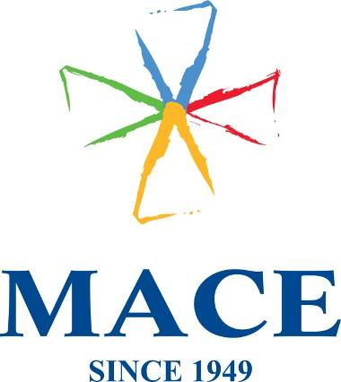

Mace (Ireland) Ltd. · Block 2, West Pier Business Campus, Old Dun Leary Road · Dun Laoghaire ·
Co. Dublin · Tel: +353 (0) 1 2802909

DELIVERY NOTE

Delivered To:
FAO: Laurena Woods
ARAMEX/TWO WAY, Bellinstown, Ballyboughall, Co Dublin
PH: 01-8078551
Packing list:
700 Hubspot Orange Cotton Tote Bag - REF: POR056371
Delivered By:
Mace (Ireland) Ltd
Michelle Roe
Block 2, West Pier Business Campus
Old Dunleary Road
Dun Laoghaire
Co Dublin

Phone: 01-2145101

BOX _____ of _____

