From: Hollie Taylor <hollie@samedaybags.com>
Sent: 05 November 2026 15:31
To: Melanie Lee <melanie@bag-co.co.uk>
Subject: Re: FW: Order request

Hi Melanie,

The customer has decided to change the Black Seabrook instead. Please could we have an order for 110 of these and drop the order for the teal bags?

Many thanks
Hollie

From: Hollie Taylor <hollie@samedaybags.com>
Sent: 05 November 2026 08:56
To: Bagco Ltd <sales@bag-co.co.uk>
Subject: Order request

Hi,

Please can we order Seabrook Recycled in the following colour:
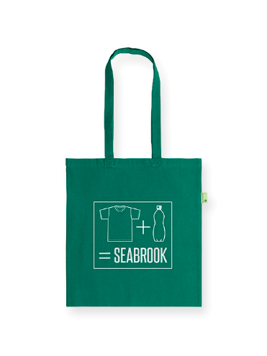
Please can we order 110 for delivery asap?

Many thanks
Hollie

