Overs on this order will not be accepted
Purchase Order  Bagco Limited  Unit 3  Church Court  Hortons Way  Westerham  Kent  TN16 1BT |  | Delivery Address  The Business Supplies Group  Unit 6 Blackdown Park  South View Estate  Willand  Devon  EX15 2FS

Purchase Order No: | 156561BUSSUP
Date: | 14/08/26

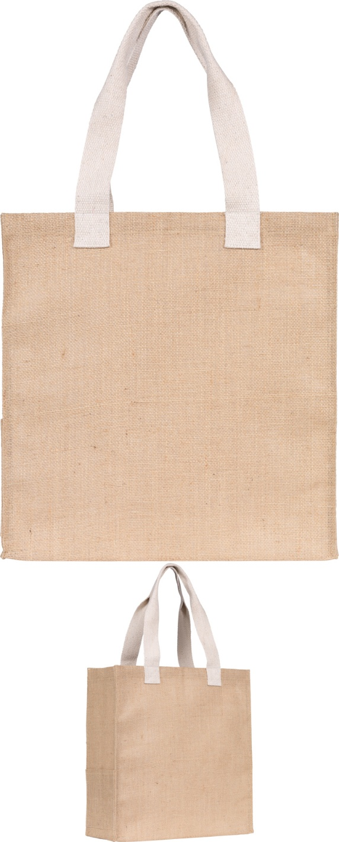 | (JU3009R) Dargate Jute Tote Bag New Natural - 2 colour 1 side
Large Eco tote shopper bag with environmentally friendly new Corn Starch backing,
made from 14x15 natural jute with a side pocket and natural coloured cotton
webbing handles.
Product Colour Natural
Product Dimensions (cms) (H)38x(W)37x(D)13 cms
Handle Length 52cm from seam to seam
Maximum Load (kgs) TBA
Volume (litres) 18.278
Max. Screen Print Colours 2
Screen Print Area (cms) (h)25x(w)22.5 cms
UV Print Area (cms) (h)22x(w)22cms
Printed 2 colour 1 side - repeat order 138207
 | Quantity | Unit Price | Set-Up | Delivery | Total | VAT @ 20%
 | 400 | 2.520 | 50.00 | 49.00 | 1,107.00 | 221.400
 |  |  |  | Sub Total | 1,107.00 | 221.40
 |  |  |  | Total | 1,328.40

Notes  All proofs and order acknowledgments to be sent to orders@tradegiftsolutions.co.uk  PDF proof to be supplied at all times |  | Pantone Information  - repeat  - .  - .  - .

