Trade Gift Solutions, 43-44 High Street, Kinver, West Midlands, DY7 6HF
Tel: 01384 878 526 | Fax: 01384 878 549 | E-Mail: sales@tradegiftsolutions.co.uk
Overs on this order will not be accepted
Purchase Order  Bagco Limited  Unit 3  Church Court  Hortons Way  Westerham  Kent  TN16 1BT |  | Delivery Address  The Business Supplies Group  Unit 6 Blackdown Park  South View Estate  Willand  Devon  EX15 2FS

Purchase Order No: | 156562BUSSUP
Date: | 14/08/26

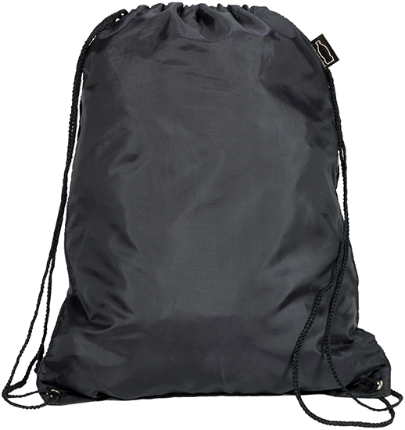 | (R5011) Eynsford Recycled Rpet Drawstring Backpack Bag Black - 1 colour 1 side
Good quality larger drawstring backsack bag made from REACH compliant Rpet
210d with PU backing. Metal eyelets and reinforced PU corners.
LT: Approx 7 working days from proof approval
1 colour 1 side - repeat 138184
 | Quantity | Unit Price | Set-Up | Delivery | Total | VAT @ 20%
 | 300 | 1.320 | 25.00 | 23.00 | 444.00 | 88.800
 |  |  |  | Sub Total | 444.00 | 88.80
 |  |  |  | Total | 532.80

Notes  All proofs and order acknowledgments to be sent to orders@tradegiftsolutions.co.uk  PDF proof to be supplied at all times |  | Pantone Information  - repeat  - .  - .  - .

