Colour

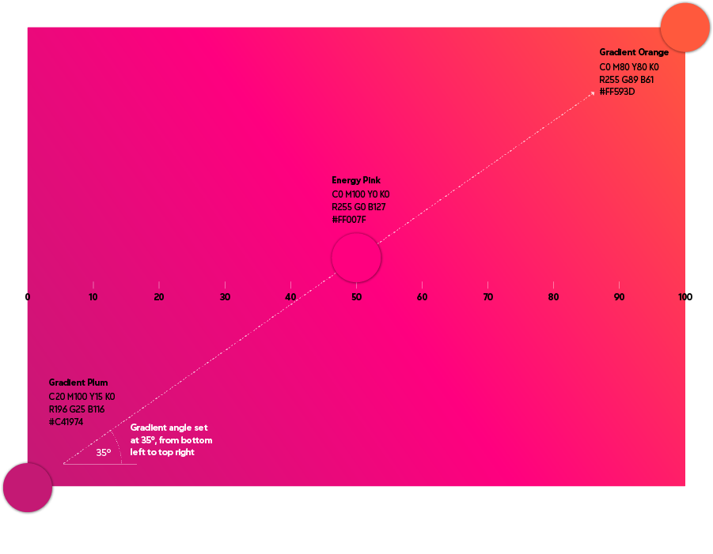

Primary pink palette
Energy pink
Pantone 226
C0 M100 Y0 K0
R255 G0 B127
#FF007F

Neutrals

