
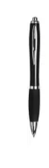
Pen
www.sclcomms.co.uk

Pad
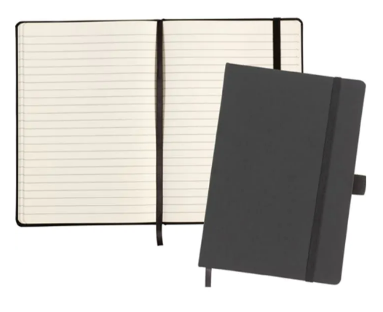



www.sclcomms.co.uk

Post-It
Specialists in IT Management
www.sclcomms.co.uk

