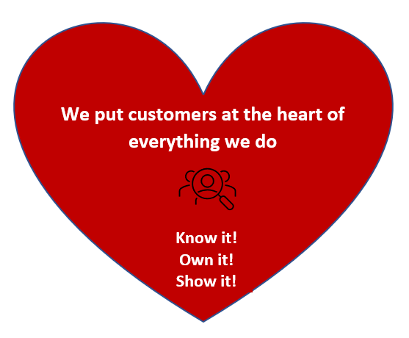



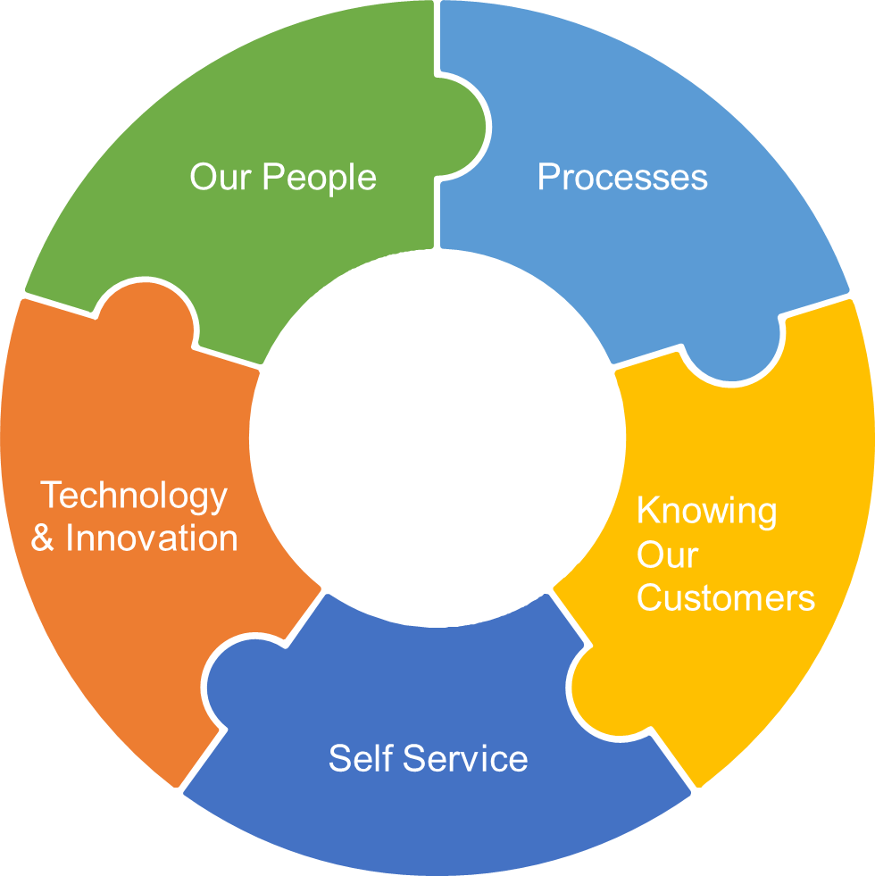
We put customers at the heart of everything we do

Knowing Our Customers
We understand and listen to our customers and act on their feedback
Our People
We develop confident, supportive and empowered teams
Processes
We make it easy for our teams to put it right first time
Self service
We make it easy for our customers to do business with us
Technology & Innovation
We equip our teams with the tools they need to deliver an outstanding customer experience

