Colours
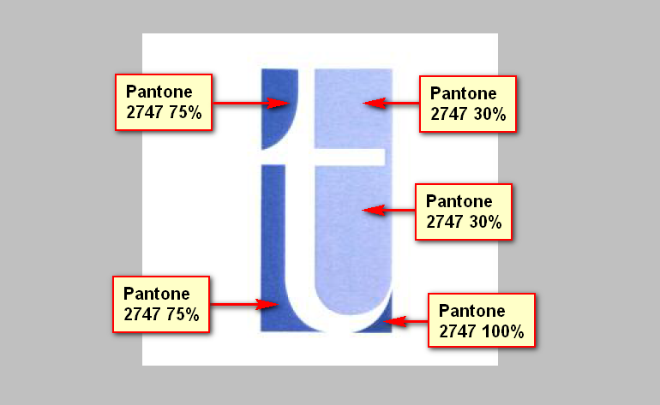

Any other text
Should all be Pantone 2747 100%

